AP Biology Name __________________________
Angiosperm Reproduction and Biotechnology
Guided Reading Chapter 38.1-38.2

- The angiosperm life cycle has three unique features: Flowers, Fruits and double Fertilization. On the diagram of a flower, label all floral parts and give the function of each. Label also the stamen and carpel. Then, circle the flower parts that are essential for reproduction.
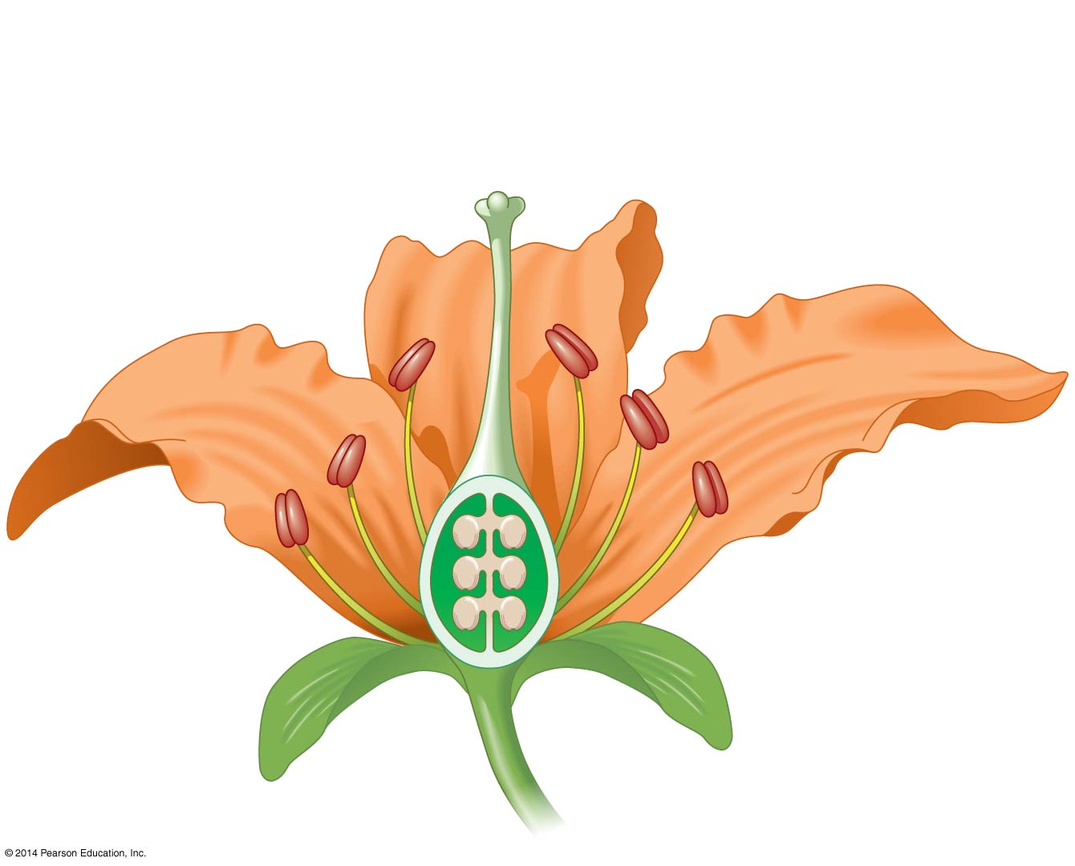
- Figure 38.3 explores four tends in the evolution of flowers. The important taskls here is to understand how the trend allows for greater evolutionary fitness by the plant. In the table below, list the four trends, then explain how the trend increases fitness.
Trend in the Evolution of Flowers | How the Trend increases Fitness

- Use the life cycle of an angiosperm in Figure 38.4, page 819, to answer the following questions:
  - By what process, inside the ovary of the carpel, will a haploid egg and two haploid polar bodies (among other cells and nuclei) form? _____________
  - By what process, inside the anther of the stamen, will each pollen grain eventually for two sperm nuclei and one pollen tube nucleus? ____________________
  - The next key process is fertilization. What is formed when a sperm nucleus combines with the egg nucleus? ________________________
  - What is the triploid (3n) tissue that is formed when the other sperm nucleus combines with both polar bodies? _______________________

- Explain the process of double fertilization.

- After double fertilization, each ovule develops into a ______________, while the ovary develops into the __________________.

- What is the difference between pollination and fertilization?

- The story of the Madagascar orchid and its pollinator is too good to miss! Take a good look at Figure 38.6. Darwin never saw this moth, but why did he make a prediction that explorers would find a moth with a 28-cm-long proboscis? (Use the term coevolution in your response.)
- A few review points:
  - The chromosome number of the endosperm is n, 2n or 3n? _________
  - The chromosome number of the zygote is n, 2n or 3n? _________
  - What is the role of the endosperm? ____________________________
  - After double fertilization, what does each ovule become? ____________
  - After double fertilization, what does each ovary become? ____________
- Let’s compare the seeds of eudicots and monocots. How many cotyledons does each type have?
- What is the function of the seed coat?

- Label the figures.
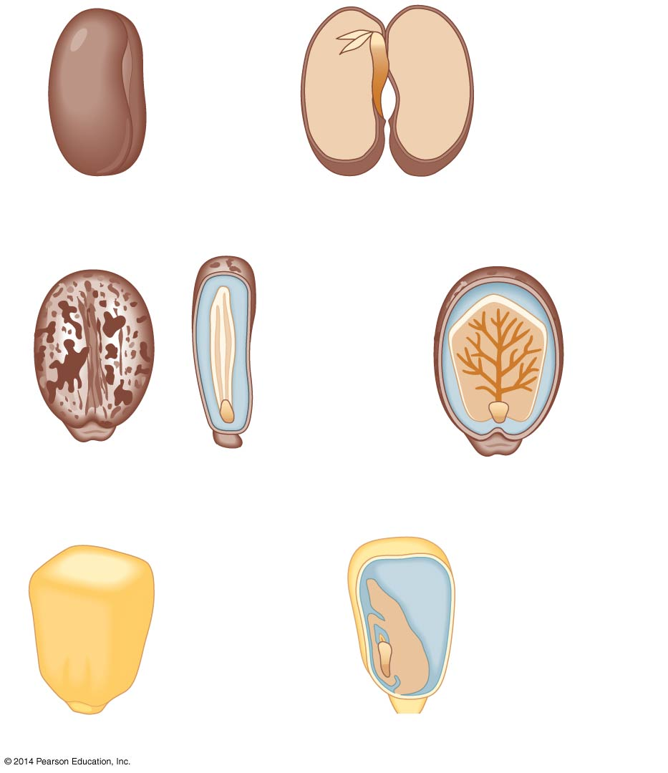
- Explain how seed dormancy is an evolutionary adaptation that increases fitness.

- What are some mechanisms that maintain seed dormancy?

- What is imbibition? How do changes in the environment result in the cues that cause molecular changes in the seed?

- To a botanist, a fruit is a ripe _______________. It does not have to be sweet! A pea pod is a fruit. A green pepper is a fruit.

- An important function of the fruit is to aid in dispersal. Using Figure 38.12, state the three primary methods of dispersal and an example of each.

- Asexual reproduction in plants is also known as vegetative reproduction. Describe two different types of sexual reproduction in plants.

- From an evolutionary perspective, what are the advantages and disadvantages of asexual and sexual reproduction in plants?

- Why is it important for plants to have mechanisms to prevent self-fertilization?

- What are two mechanisms to prevent self-fertilization?

